EXTERNAL LAB TEST-AI ASSISTED CODING
SET2:
Question1:

Provide a one-shot example to ChatGPT to generate code that sorts a list of dictionaries by a specific key (e.g., "marks"). Test the output.

PROMPT:
Generate Python code that takes a list of dictionaries containing student names and their marks, then sorts the list in ascending order by the key "marks". After sorting, print each dictionary in order.
CODE WITH OUTPUT:
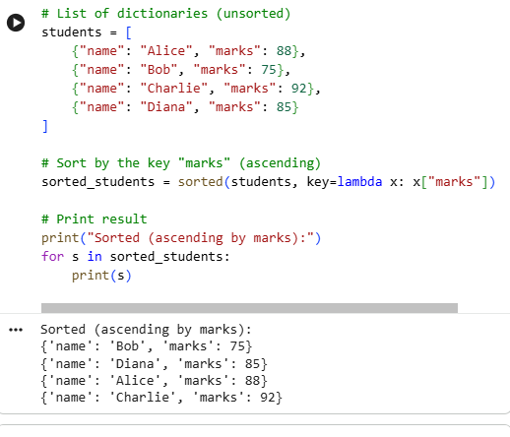

EXPLANATION:
- students = [...]: This line initializes a list named students, where each item is a dictionary containing a student's name and marks.
- sorted_students = sorted(students, key=lambda x: x["marks"]): This sorts the students list. The key=lambda x: x["marks"] tells Python to use the value of the 'marks' key in each dictionary as the basis for sorting, in ascending order.
- print("Sorted (ascending by marks):"): This simply prints a descriptive header to the console.
- for s in sorted_students: print(s): This loop then iterates through the sorted_students list and prints each sorted student dictionary on a new line.
The code in the cell 7518cdca executed successfully! Here's a breakdown of the output:
- Sorted by marks (ascending): The first part of the output shows the students list sorted based on their 'marks' from lowest to highest. You can see 'Bob' (85 marks) is first, followed by 'David' (88), 'Alice' (90), and 'Charlie' (95).
- Sorted by name (descending): The second part of the output sorts the students list alphabetically by their 'name' in reverse order (descending). So, 'David' comes first, then 'Charlie', 'Bob', and 'Alice'.
QUESTION2:
Perform a Copilot-assisted debugging session by intentionally introducing an error and fixing it through AI suggestions.
CODE WITH OUTPUT:
With intention error-
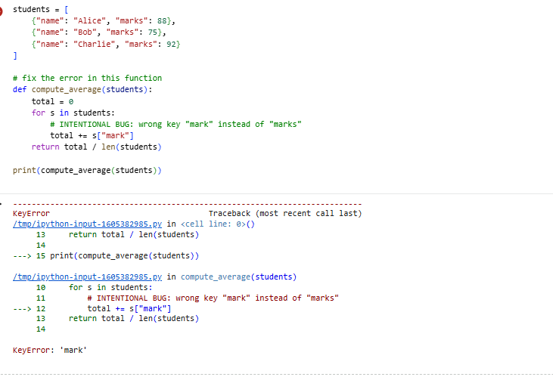
AI fixed Error-
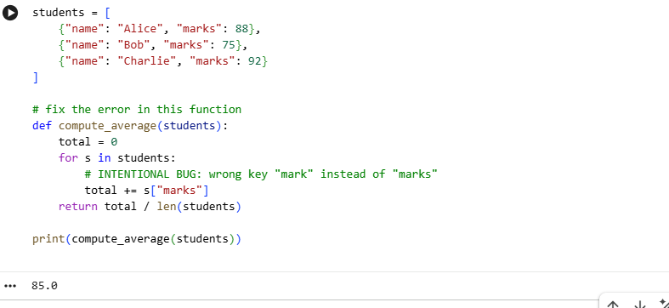
EXPLANATION:
